

**Western Australian Certificate of Education**

**ATAR course examination, 2019**

**Question/Answer Booklet**

12 PHYSICS

Name

**Test 1 – Projectile & Circular Motion**

|  |  |  |  |  |  |  |  |  |  |  |
| --- | --- | --- | --- | --- | --- | --- | --- | --- | --- | --- |
| Student Number: In figures |  |  |  |  |  |  |  |  |  |  |

**Mark: $\frac{}{\text{4}\text{7}}$**  In words

#### Time allowed for this paper

Reading time before commencing work: five minutes

Working time for paper: sixty minutes

**Materials required/recommended for this paper**

To be provided by the supervisor

This Question/Answer Booklet

Formulae and Data Booklet

***To be provided by the candidate***

Standard items: pens, (blue/black preferred), pencils (including coloured), sharpener, correction fluid/tape, eraser, ruler, highlighters

Special items: non-programmable calculators satisfying the conditions set by the School Curriculum and Standards Authority for this course

**Important note to candidates**

No other items may be taken into the examination room. It is your responsibility to ensure that you do not have any unauthorised notes or other items of a non-personal nature in the examination room. If you have any unauthorised material with you, hand it to the supervisor before reading any further.

**Structure of this paper**

|  |  |  |  |  |  |
| --- | --- | --- | --- | --- | --- |
| Section | Number of questions available | Number of questions to be answered | Suggested working time  (minutes) | Marks available | Percentage of exam |
| Section One:  Short Answers | - | - | - | - | - |
| Section Two:  Problem-solving | 10 | 10 | 60 | 47 | 100 |
| Section Three:  Comprehension | - | - | - | - | - |
|  |  |  |  | **Total** | 100 |

**Instructions to candidates**

1. The rules for the conduct of examinations at Holy Cross College are detailed in the College Examination Policy*.* Sitting this examination implies that you agree to abide by these rules.

2. Write your answers in this Question/Answer Booklet.

3. Working or reasoning should be clearly shown when calculating or estimating answers.

4. You must be careful to confine your responses to the specific questions asked and to follow any instructions that are specific to a particular question.

5. Spare pages are included at the end of this booklet. They can be used for planning your

responses and/or as additional space if required to continue an answer.

• Planning: If you use the spare pages for planning, indicate this clearly at the top of the page.

• Continuing an answer: If you need to use the space to continue an answer, indicate in the original answer space where the answer is continued, i.e. give the page number. Fill in the number of the question(is) that you are continuing to answer at the top of the page.

6. Answers to questions involving calculations should be ***evaluated and given in decimal***

***form*.** It is suggested that you quote all answers to ***three significant figures***, with the

exception of questions for which estimates are required. Despite an incorrect final result, credit may be obtained for method and working, providing these are ***clearly and legibly set out***.

7. Questions containing the instruction "estimate" may give insufficient numerical data for their solution. Students should provide appropriate figures to enable an approximate solution to be obtained. Give final answers to a maximum of two significant figures and include appropriate units where applicable.

8. Note that when an answer is a vector quantity, it must be given with magnitude and direction.

9. In all calculations, units must be consistent throughout your working.

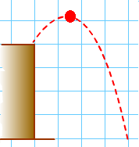1. A boy projects a ball from a bench as shown here. Draw **ALL** forces acting on the ball at the moment shown in the diagram.

Note: Make sure the forces are shown clearly on the diagram. [1 mark]

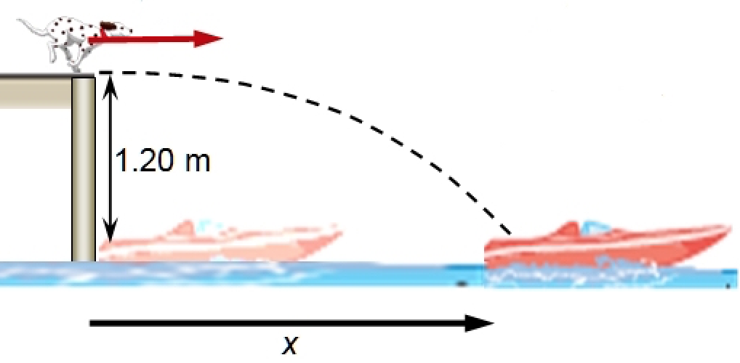

2. The family dog runs horizontally off the end of the dock at a speed of 6.70 ms-1 with the intention of landing in the boat that is 1.20 m below the end of the dock.

Find the maximum horizontal displacement ***x*** that the boat can be from the end of the dock without the family winding up with a wet dog. [4 marks]

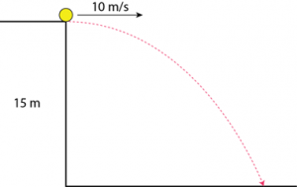3. A football is kicked horizontally from the edge of a cliff into a river below with a speed of

10.0 ms-1, as shown here. Calculate the velocity with which the ball enters the water. [5 marks]

4. The picture shown below shows a stroboscopic photograph of a tennis ball moving in a parabola. The time interval (Δt) between each flash is 0.0482 sec. At the time t = 0, the ball is at the origin (0,0).

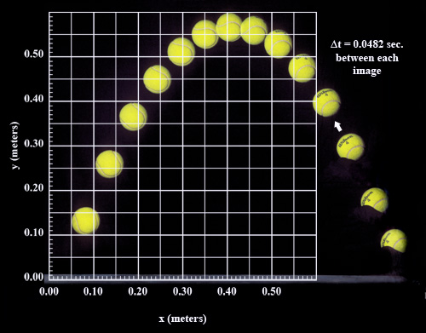

(a) Use the picture (previous page) to calculate the time taken for the ball to reach its maximum height. [1 mark]

(b) Calculate the ball’s initial vertical speed. [1 mark]

(c) Calculate the ball’s initial horizontal speed. [1 mark]

(d) Draw a vector diagram of the ball’s initial motion in the space provided here. [2 marks]

(e) Calculate the initial velocity of the tennis ball. [3 marks]

5. Figure 3 shows the trajectory of a cannonball fired from a cannon.

Neglecting air resistance, which set of vectors (shown below), represents the horizontal and vertical components of the cannonball’s velocity along the trajectory? (***Circle your answer*.**) [1 mark]

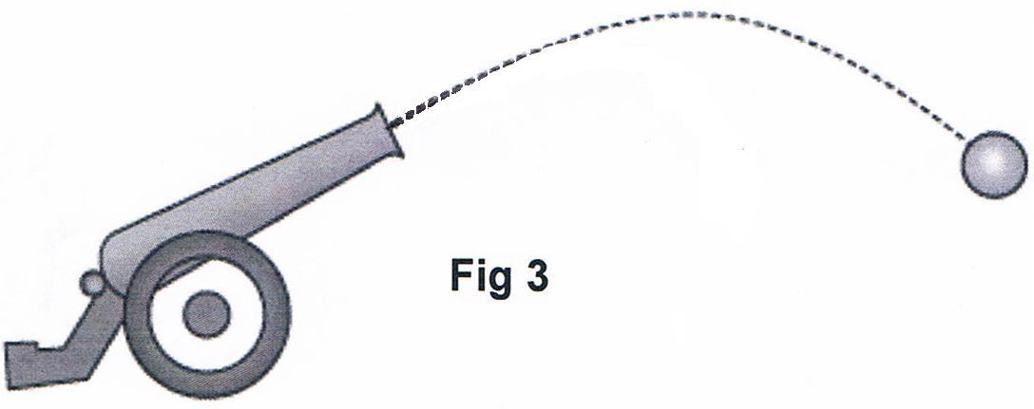

|  |  |  |  |  |  |  |  |  |
| --- | --- | --- | --- | --- | --- | --- | --- | --- |
|  | **Horizontal plane** | | | | **Vertical plane** | | | |
| A | 1arrow2014 | 1arrow2014 | 1arrow2014 | 1arrow2014 | 1arrow2014 | 1arrow2014 | 1arrow2014 | 1arrow2014 |
| B | 1arrow2014 | 1arrow2014 | 1arrow2014 | 1arrow2014 | 1arrow2014 | 1arrow2014 | 1arrow2014 | 1arrow2014 |
| C | 1arrow2014 | 1arrow2014 | 1arrow2014 | 1arrow2014 | 1arrow2014 | 1arrow2014 | 1arrow2014 | 1arrow2014 |
| D | 1arrow2014 | 1arrow2014 | 1arrow2014 | 1arrow2014 | 1arrow2014 | 1arrow2014 | 1arrow2014 | 1arrow2014 |

6. A boy kicks a football off the edge of a cliff and into a lake with a speed of 20.0 kmh-1 and at an angle of 35.0° to the horizontal. The cliff is found to be 17.0 m above the surface of the lake.

(a) What is the maximum height reached by the ball above the lake? [4 marks]

(b) Calculate the vertical velocity of the ball as it hits the surface of the lake. [2 marks]

(c) Calculate the resultant velocity of the ball as it hits the surface of the lake. [4 marks]

7. A 1.40 x 103 kg car rounds a flat circular corner of radius 95.0 m.

(a) If the friction between the tyres and the road is 7.55 x 103 N, what is the maximum speed at which the car can travel? [2 marks]

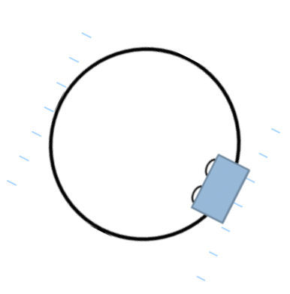

This is a top view of the car in the previous question which is travelling in a ***counter-clockwise*** circle.

(b) Draw and label clearly the direction of ***velocity*** and ***acceleration*** of the car at this point. [2 marks]

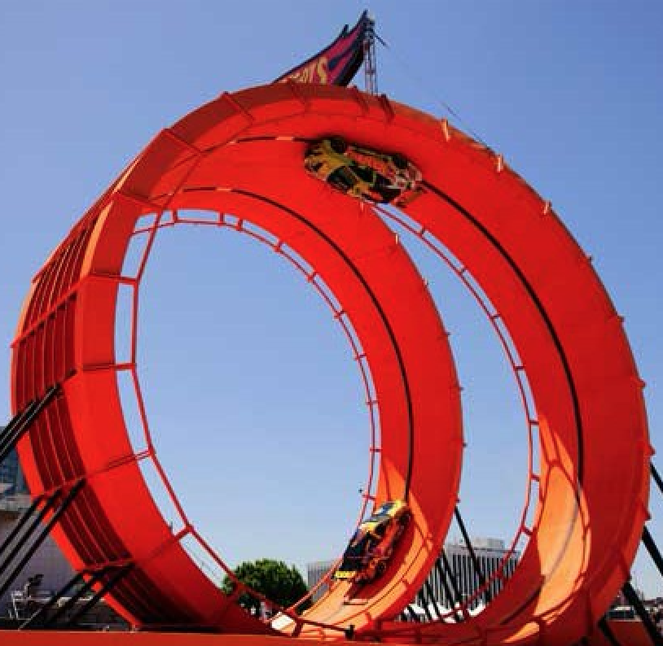8. In 2012, the Hot-Wheels Toy Company executed a car stunt where a typical family car successfully performed an inverted loop on a specially designed 48.0 m loop.

At the top of the loop, the 5.00 x 102 kg car is just in contact with the road. What is the minimum velocity required to keep the car in contact with the road at this point? [3 marks]

9. A cyclist is riding around a velodrome. The radius of the corner is 46.0 m. The track around the corner is banked at 50.0°. How fast must he ride so that he does not rely on friction to provide centripetal force? ***Include a labelled vector diagram***. [3 marks]

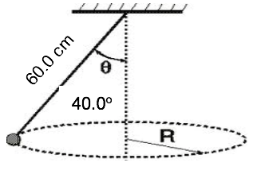

10. A conical pendulum consists of a small 55.0 g ball on a thin string of length 60.0 cm.

(a) Calculate the tension in the string [3 marks]

(b) Calculate the magnitude of the nett force (centripetal force) acting on the ball.

[If you did not manage to calculate the tension in part (a), you can use a value of

0.800 N.] [2 marks]

(c) How fast is the ball travelling in its circular path? [3 marks]